Pokhara University

Level: Bachelor | Semester – Fall | Year : 2008
Programme: BE |  | Full Marks : 100
Course: Electronic Circuits |  | Time : 3hrs.

Candidates are required to give their answers in their own words as far as practicable.
The figures in the margin indicate full marks.

Attempt all the questions.

1. | - What is a multistage amplifier circuit? What are the various coupling schemes of two stages of amplifiers? Briefly Explain RC Coupling method.  - Calculate the Voltage gain (VL/VS) for the cascade BJT amplifier given below.  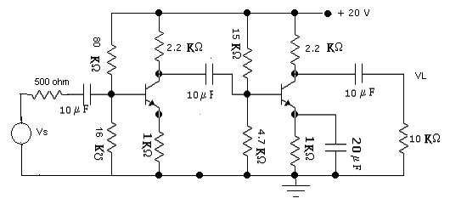 | 8  7
2. | - What is Millers-effect? Prove that C_{M} = C_{C} (1-A_{V}) ,Where C_{C} is capacitance connected between the input and the output of an amplifier, A_{V} is voltage gain and C_{M} is miller capacitance. How this affects the high frequency response of inverting amplifier.  - Explain class-B operation and explain how this concept is utilized in push-pull amplifier. Draw complementary symmetry class B push pull amplifier ad explain its operation. | 8  7
3. | - State advantage and disadvantages of negative feedback. "How negative feedback provides better stability?" Explain.  - Describe Wein Bridge oscillator. Draw necessary circuit diagram and derive the expression of its resource efficiency. | 8  7
4. | - What are the main characteristics of an ideal operational amplifier? For the given circuits, find out the output voltages.  - 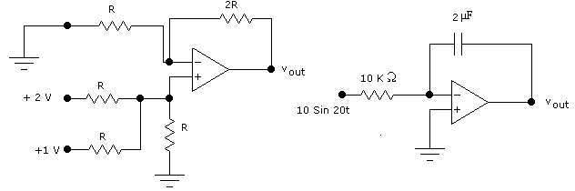Draw Astable Multivibrator and explain its operation. | 4+4  7
5. | - Draw the fundamental circuit diagram of a logarithmic amplifier. Derive expression for output voltage. Why O/P voltage varies with temperature? Give reasons.  - Draw R-2R ladder network and explain its operation. | 8  7
6. | - What do you mean by Regulated Power supplies? Briefly explain switched mode voltage Regulator.  - What is regulated power supply? Calculate the output voltage and zener current in the regulator circuit shown below. Assume V_{Z} = 8.3V, and β = 100.  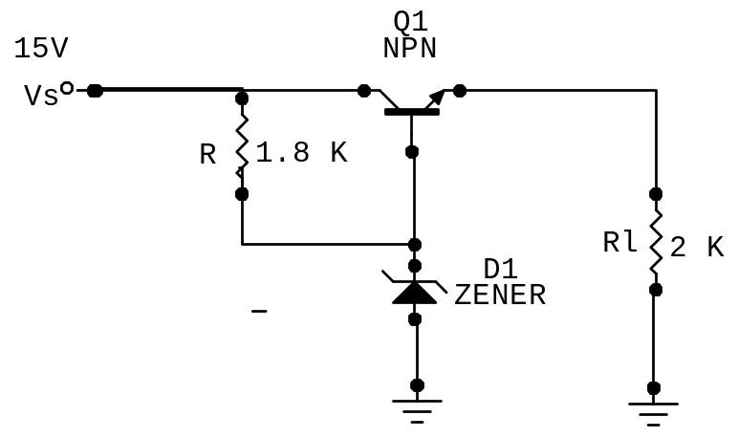  - Draw Schmitt trigger circuit and explain its operation. | 5  5  5
7. | Write short notes on (Any Two)  - Voltage controlled oscillator  - Common mode and differential mode gain of Emitter Coupled differential Amplifier  - Effects of by pass Capacitor in frequency Response. | 5×2

